Compassion to Self
What you do for yourself… any gesture of kindness, any gesture of gentleness, any gesture of honesty and clear-seeing toward yourself… will affect how you experience your world. In fact, it will transform how you experience the world.
~Christina Feldman
We are fundamentally good. When you come to think of it, that’s who we are at the core…What difference does goodness make? Goodness changes everything… Goodness changes show we see the world, the way we see others, and most importantly, the way we see ourselves.
The way we see ourselves matters. It affects how we treat people. It affects the quality of life for each and all of us.
For each kindness enhances the quality of life.
Each cruelty Diminishes it.
~South African archbishop Desmond Tutu
We feel the rhythm of compassion moving in and out, connecting us to the eternal rhythm of life.” ~Gail Straub, The Rhythm of Compassion

Self-compassion:
How we are loving, comforting, and caring for ourselves when we are hurting.

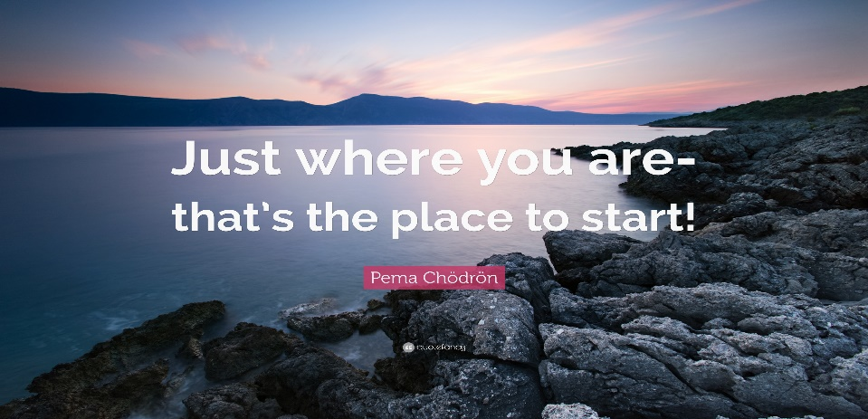
How we approach our limitations & failures
- How we look upon ourselves, the judgments we make about self.

What we bring that needs self-compassion
- Acceptance of our less than perfect self
- External, difficult events & experiences that cause us sorrow and suffering
- Inner turmoil and pain only we know
- Difficulties with relationships
- Issues of self-worth and self-esteem that go back to early childhood
- Acceptance of our physical self, how we look, how the body changes

Metaphors:
- Feather, preening ourselves
- Spruce tree
- Dove and how it cares for itself

Pause: What strikes you about self-compassion so far?
What metaphor speaks to you? (Any not just what we mentioned)
What do you identify with so far?

What Compassion is Not
- Not self-centered
- Not self-pity
- Not self-gratification
- Not the same as self-esteem
~ A Fearless Heart, Thupten Jinpa

What Keeps Us From Being Compassionate To Self

- Taught to always put others before self

Self-Compassion of Jesus
- “Jesus, tired, sat down by the well”
- “At daybreak, he departed and went into a deserted place”
- Mountainside prayer
- Into the boat to get away from the crowds
- Sleeping in the boat
- Receives the anointing of the tears (and the oil)
- Spends time at the home of Mary, Martha and Lazarus
- Weeps over the death of Lazarus
- Protects himself
- Asks for support in his agony in the garden
- Entrusts his mother to John
- Forgives the repentant thief on the cross

- Family of origin – (messages spoken and unspoken)
  - Boy Who Was Raised as a Dog
- Western culture’s attitude toward self-compassion (Happiness is all)

Pause: Any of this you can relate to?
Take a minute to reflect and write an experience(s) that formed you?

Aspects Of Offering Compassion To Our Self

- Deep listening to self - (awareness / mindfulness)

Wisdom of the self
“…apprentice yourself to yourself, begin to welcome back all you sent away, be a new annunciation, make yourself a door through which to be hospitable, even to the stranger in you.” (from “Coleman’s Bark”, poem by David Whyte)

- Approach self in non-judgmental way
  - Refer to Macrina quote handout
  - Deeper layer to understand
  - Soften our hearts
  - Do we listen to ourselves
  - Self-compassion vs self-indulgence
  - Colemans Bark – poem by David Whyte
Embracing Our Shadow,
Lloyd

The Notion of Perfection…The notion of perfection can keep us from being compassionate toward self…

“If I could become perfect…I would be worthy of love and acceptance…” ~Christina Feldman

- Let go of to be compassionate to self

Things we need to let go of in order to have healthy self-compassion:
- Shame, concern about disgrace, failure…
- Scarcity
- Exhaustion as a status symbol
- Anxiety as a life style
- Self-doubt and “supposed to”
- Being cool and “always in control”
~ Brené Brown

- An inability to Receive
- Be willing to forgive ourselves
Three Core Components of Self-Compassion
- Self-kindness vs Self-Judgment
- A recognition of our common humanity
- Mindfulness
~ Self-Compassion, Kristen Neff
Pause: Spend time reflecting on the ways we show self compassion and identify the 2 or 3 that are part of your life? And the 2 or 3 that you would like to work on developing more for yourself.
Compassion for Self (Summary)
- Respect for self
- Attentiveness to where and how we hurt
- Taking care of body, mind, and spirit
- Listening to our thoughts and feelings without negative judgment
- Acknowledge failings/forgive self
- Be kind to self especially when in distress
- Listen without negative judgment
- Be present and patient with struggles
- Stay with self in times of pain/grief
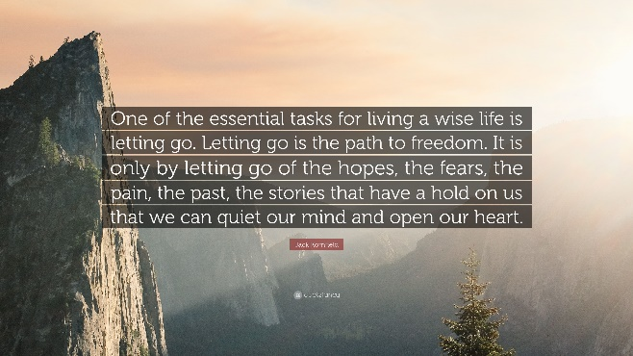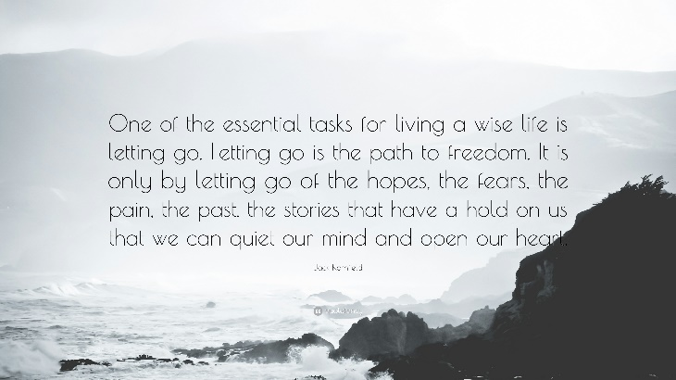
Using The 3 Aspects Of Compassion To Deepen Self Compassion

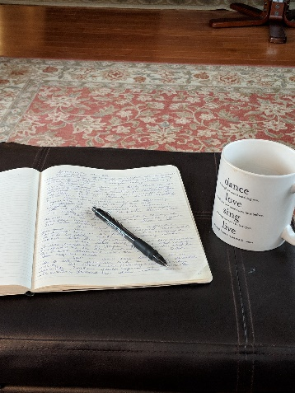
AWARENESS
Deep listening to yourself- Mindfulness of the beloved)
1. Journal keeping,
2. Personal reflection,
3. Conversation with others

Self-Soothing when overwhelmed
1. Takes a minimum of 20 minutes to get brain back
2. Pay attention to breathing;
3. Exercise if needed but always return to breath
4. Become aware of internal messages
( non-violent, forgiving, non judgmental.

Compassion fatigue - the stress and strain due to caring for others who suffer in some way. Burnout = daily stress and strain from being overworked in any aspect of life

“attachment fatigue… “We wear ourselves out when we’re attached to the outcome
of our hard work, such as the success or recognition.” ~ Christopher Germer

If I come to you in pain and you end up with the same pain all we have done is add to the world’s suffering….I want you to understand my pain, to respond to it deeply, but not take it on yourself. I want you to help me see what you see and what I cannot see… Mirror my experience, but don’t embrace it as your own. ~ Rabbi Rami Shapiro
What you do for yourself… any gesture of kindness, any gesture of gentleness, any gesture of honesty and clear-seeing toward yourself… will affect how you experience your world. In fact, it will transform how you experience the world. ~Christina Feldman
Pause: What is something you could do to be more aware of compassion to yourself?

ATTITUDE
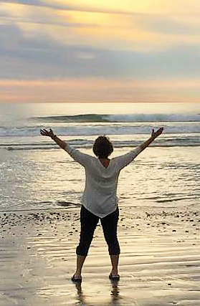
Welcome back the parts of yourself you sent away.
- Be kind to the stranger within yourself.
- What could be the positive side of shadow as much as what
is the shadow of the positive.
- Brains are like Velcro with negative thoughts and like Teflon with positive thought. Need to savor positive thoughts for at least 15 seconds to be imprinted into brain.
- Acknowledge self-issues without beating self up.
- Wonder: “What am I learning?”

- Embarrassment is a doorway to grace. Power of forgiving self
- Perfect means being whole. The integration of all of self.

“We live from a place of worthiness. We cultivate the courage, compassion and connection to get up in the morning and think no matter what gets done and how much is left undone, I am enough. Yes, I am imperfect and vulnerable and sometimes afraid, but that doesn’t change the truth that I am also brave and worthy of love and belonging.” ~Brene’ Brown

Pause: What part of yourself do you need to ‘Welcome Back’

ACTION
Find Balance in life by letting go of:
- Shame
- Scarcity (I’m not enough)
- Exhaustion as a status symbol
- Anxiety as a life style
- Self-doubt
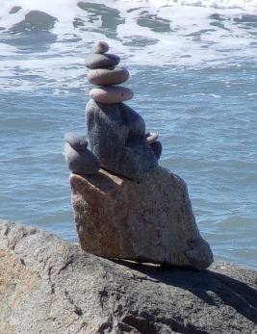
- Being cool by always being in control.
- Grow the ability to receive.
- Open self to receive from others.
- By not accepting the help we deny the gift of showing compassion by the other.
- Go to a still place.
- Meditation.
- Contemplation.
- Sit quietly remembering God’s loving gaze.
- Grace moves through me from God for myself and the other.

The time will come
when, with elation,
you will greet yourself arriving
at your own door,
in your own mirror,
and each will smile at the other’s welcome,
and say, sit here. Eat.
You will love again the stranger who was yourself.
Give wine. Give bread. Give back your heart
to itself, to the stranger who has loved you
all your life, whom you ignored
for another, who knows you by heart.
Take down the love letters from the bookshelf,
the photographs, the desperate notes,
Peel your own image from the mirror.
Sit. Feast on your life.
~ Derek Wolcott
Pause: What is one or two actions you can do to nurture compassion to yourself?
Personal Boundaries, Suzanne LaCombe
Any aspect of our interactions with others, Includes our relationship with ourselves (self-sabotage) and with our environment (noise and other stimuli)
“Boundaries reflect our core values, our respect for ourselves and our need for safety and protection. They include being able to say no and mean it or saying yes and meaning it. They are a way of defining ourselves separately from others.”
Protect self by more than saying “no.”
Protect self from other’s negativity.
Protect self from unhealthy expectations.
Protect self from being consumed by emotion.
Protect self from false flattery
Protect self from false promises.

Caring for Self
- Faithfulness to daily spiritual practice
- Boundaries, Boundaries, Boundaries
- Trust that difficult things can be a source of growth
- Have an objective person with whom to share
- Awareness of mental scenarios
- Befriend emotional/mental turmoil
- Attentiveness to physical pain
- Get enough sleep, exercise, healthy food
- Make positive affirmations

16 Warning Signs of Trauma Exposure Response

- Feeling hopeless and helpless
- A sense that one can never do enough
- Hyper-vigilance
- Diminished creativity
- Inability to embrace complexity
- Minimizing
- Chronic exhaustion/physical ailments
- Inability to listen/deliberate avoidance
- Dissociative moments
- Sense of persecution
- Guilt
- Fear
- Anger and cynicism
- Inability to empathize
- Addictions
- Grandiosity

Loving Kindness Prayer

Loving-kindness to self
May I abide in loving kindness.
May I be free of suffering.
May I receive what I need.
May I be at peace.
Loving kindness to another (a loved one)
May you abide in loving kindness.
May you be free of suffering.
May you receive what I need.
May you be at peace.

Loving-kindness to the world
May all beings abide in loving kindness.
May all beings be free of suffering.
May all beings receive what they need.
May all beings be at peace.
If we can learn to be kind and relate to ourselves with a caring mentality – to send ourselves helpful messages when things are hard for us – we’re more likely to stimulate those parts of the brain that respond to kindness. This will help us cope with stress and setbacks.
- Paul Gilbert

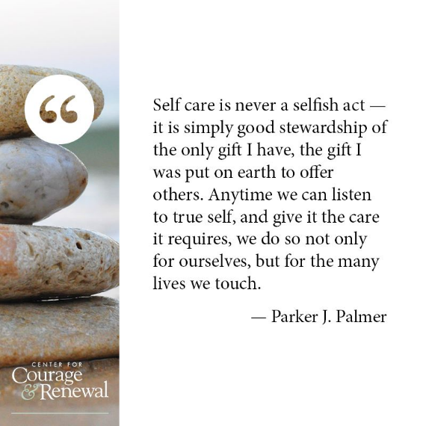

Extras
Handouts in packet:

- Compassion to Self questions and How Do You Feel exercise
- Circle of Self Compassion
- Jesus and Self Compassion
- Bowl image and exercise
- Macrinas prayer

Meditation:
- Something from Joyce’s prayer book
- Maybe a song video

Music:
- Karen Drucker
  - I Am A Gift: https://www.youtube.com/watch?v=Q3lMGfWHPG0&list=PL10dX-GXbgrZ5zRrTWi2QrMzO-YV8NOsW&index=19
  - I See the Beauty in You https://www.youtube.com/watch?v=m5Jz6gLDOhg&list=PL10dX-GXbgrZ5zRrTWi2QrMzO-YV8NOsW&index=13
  - I’M Gentle with Myself: https://www.youtube.com/watch?v=qp3LCCy96_Ihttps://www.youtube.com/watch?v=qp3LCCy96_I
- Jan Philips:
  - I Will Not leave you Comfortless: https://www.youtube.com/watch?v=k0Pf6lWRp8w
- Sarah Thomsen
  - Oh Spirit Guide Me Now: https://www.youtube.com/watch?v=tUJ8HrsIytM

Video’s for reflection
- Three part series from Sound True featuring Kristen Neff & Chris Germer
https://product.soundstrue.com/power-of-self-compassion/why-self-compassion-is-important/?sq=1&_ke=eyJrbF9lbWFpbCI6ICJyYnVzc2FuQHNtbXNpc3RlcnMub3JnIiwgImtsX2NvbXBhbnlfaWQiOiAiSk1EZ2FxIn0%3D

TedTalk: How Self Forgiveness Leads to Light, Love and a Joyful Life! | Eileen Timmins | https://www.youtube.com/watch?v=p-at-yS6eaU

TedTalk: How Self-Forgiveness Saved My Life | Josh Galarza: https://www.youtube.com/watch?v=7hzA9jrmk7s

TedTalk: Embracing the mess -- how compassion saved my life | Garrard Conley: https://www.youtube.com/watch?v=JmCtZz-RztQ

Comments:
- I often use a song video to be opening prayer and set focus - This also entails breathing exercise to get focused
- If there is time I use the handouts as part of reflection time – but I do explain them especially the bowl and circle. Often I show them mine as an example. They can design there own bowl, however.
- Again – I give the handout without the notes/pause questions. Or I can do the questions on their handout.
- I often use another song as a closing prayer because there are awesome music video’s for this topic

Created by: Bobbi Bussan, OSB. rbussan@smmsisters.org

