

**Compassion As A Way of Life**

**Opening prayer:**

**Compassion…**

[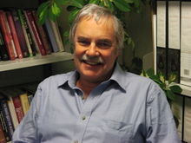](https://en.wikipedia.org/wiki/Paul_Gilbert_(psychologist)) “being sensitive to the suffering of self and others with a deep commitment to try to prevent or relieve it.”

~ Paul Gilbert, *Mindful Compassion*

**A way of life**

1. “inside-out” movement
   * An inner posture
   * And a desire to move that attitude into action.

2. A transformative process with Divine Love Empowering

* + Daily Renewal (contemplative prayer or ……)
  + Leads to persistent and insistent efforts

**To have faith is to**

1. Allow oneself to be overwhelmed by the power of God

(b) To permit the divine energy to reign at all levels of one’s being

(c) With radical change of life and vision

(d) To find the true self by letting go of the old center. ~ Bishop Robert Barron

**Compassion** is not a (psychological) state or an emotion but an understanding. It is an understanding rooted in the classroom of our lives and hearts and in a genuine investigation of our own relationship to pain and suffering. ~ Christina Feldman, *Boundless Heart*

The joys and hopes, the sorrows and anxieties of the women and men of this age, especially the poor and those afflicted in any way, are the joys and hopes, the sorrows and anxieties of the follower of Jesus Christ. *Gaudium et Spes, (Joy and Hope)* Vat. II Documents

**God of Compassion**

“the one who goes to the four corners of the earth and will not rest as long

as there are human beings with tears in their eyes.” (McNeill, Morrison, Nouwen)

**Pause DVD:**

1. **Emphasize the relationship ‘inside-out’ and maybe a personal example**
2. **Other comments I might have**
3. **Could ask about compassionate experience they had.**

**Three Movements of Compassion**

1. Bringing attention **or awareness** to recognize that there is suffering (cognitive)

1. Feeling emotionally moved by that suffering (affective)  **Attitude**

*** might be using our will, not necessarily with feelings

Wishing there to be relief from that suffering (intentional)

1. A readiness to take **action** to relieve that suffering (motivational)
   1. *Tough compassion*
   2. *Being/presence/prayer*
   3. *Doing in big or little ways*

~ Hooria Jazaieri, Compassion Cultivation Training (CCT) Stanford U.

**Pause DVD**

1. **Go into more detail on the movement giving personal examples as this is first key to becoming compassionate presence**
2. **Could have an additional handout that is from Communication with Compassion: The four elements**

**How We Are Interrelated**

* Biology / physical aspects
* Quantum physics / photons / field of energy
* Neuroscience / the brain in the heart

**Entrainment:** become attuned / connected

**“entanglement”**

* When particles are entangled the actions of one will always influence the other

in the same or opposite direction, no matter how far apart they are separated.

* “Nothing exists independently… The closer scientists look, the more they discover how dependent on, and finally indivisible from, everything is with everything else.”

~Lynne McTaggart

**Morphogenic Field**

It is my conviction that we can and must participate consciously in strengthening the morphogenic field of new consciousness that has emerged. The new field is here; it is already filled with energy; and when we become aware and attend to it, it lures us in with its power. Our past experiences have prepared us for its coming, and our conscious participation strengthens its energy. It is a morphogenic field rooted in and characterized by love – what we may call a Field of Compassion. $\sim$ Judy Cannato Field of Compassion)

**With every waking moment we are taking in someone else’s light!** ~ Lynne McTaggart

(based on the scientific theory of Fritz- Albert Popp)

Brain = physical body part

Mind = vibrations electrical impulses

(signals that go back and forth)

Neurons = primary cells of the nervous system…. one trillion cells

Synapses = the neuron connections

“Our capacity to be a cause for suffering and our capacity to end suffering live side by side within us.” (Christina Feldman)

Pause DVD

1. **‘The Hula Hoop Effect’ – examples and emphasize the importance of how we interact with each other without consciously recognizing the shared space or ‘field’.**
2. **Note the handout in their packets that explains this more in detail**

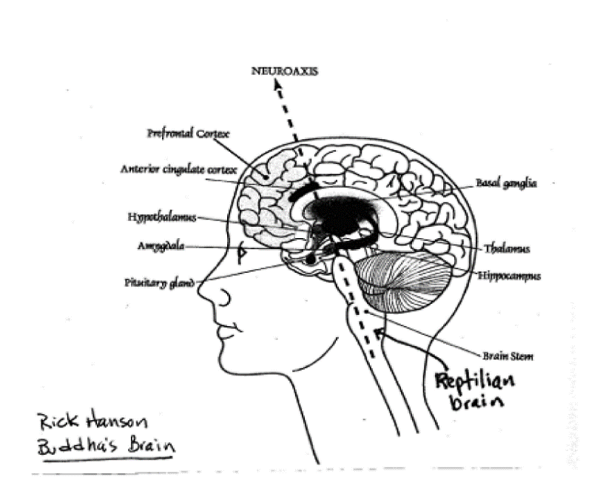

**Reptilian (early) part of brain:** Fight Flee Feed Reproduce

**Limbic system:** Emotional responses

**Neo-cortex, outer, newer part of brain:** (particularly the frontal lobe)

Think, discern, choose, decide, act

**To grow** into the person that your deepest longing desires is a great blessing.

If you can find a creative harmony between your soul and your life,

you will have found something infinitely precious. … If you can awaken the eternal beauty and light of your soul, then you will bring light wherever you go. The gift of life is given to us for ourselves and also to bring peace, courage and compassion to others. (John O’Donohue )

“Kindness, gentleness, warmth and compassion are like vitamins for our minds.” ~ Paul Gilbert

What we repeatedly think shapes our world. Out of compassion, substitute healthy thoughts for unhealthy ones. ~ Jack Kornfield

**Pause DVD**

1. **Question or answer and time to look at it a bit as the DVD goes by quickly**
2. **Introduce next section on Seeds of Compassion**

**Seeds**

**of**

**Compassion**

**Non-violent**

“Nonviolence means avoiding injury to anything on earth, in thought word, or deed” ~ Mohandas Gandhi

**Forgiveness is not:**

Forgetting

Excusing

Accepting

Denying

Or numbing yourself to pain.

Forgiveness is letting go. Letting go means that you do not cling to memories and feelings.

~ Rabbi Rami Shapiro

**Mindfulness:** How we focus our attention is the key to promoting integrative changes in the brain. ~ Daniel Siegel

You cannot solve any problem in the same state of awareness in which it was created. ~ Albert Einstein

The words your mind thinks become the house your heart lives in.~ Ann Voskamp

**Pause for discussion**

1. **Emphasis on the important of seed**
2. **Do a reflection music video on seeds**
3. **Add to the ritual of putting seeds in the dirt we started off with in the introduction time**

**The Hub of Awareness:** *Mindsight,* Daniel Siegel

**The hub**: the core or inner place of the mind from which we become aware; it’s a visual metaphor for our prefrontal cortex.

**The spokes:** how we direct our attention to a particular part of the rim

**The rim:** anything we can pay attention to, such as our thoughts, feelings, or our perceptions of the outside world, or body sensations

**Try this four-part practice:**

1. notice an upsetting emotion,
2. name it without analyzing or reflecting on it
3. identify the event that triggered it,
4. give up the underlying emotional program: the desire to control, the desire for approval and affection, or the desire for security.

~ Thomas Keating

**I read this below and we discuss it…as a closing. Gave them as a handout.**

** “The Mothers”**

**Käthe Kollwitz**

Heather Hess, [German Expressionist Digital Archive Project](http://www.moma.org/germanexpressionism), German Expressionism: Works from the Collection. 2011.

In 1919, Käthe Kollwitz began work on *Krieg* (War), her response to the tragedies endured during what she called those "unspeakably difficult years" of World War I and its aftermath. The portfolio's seven woodcuts focus on the sorrows of those left behind—mothers, widows, and children. Kollwitz had struggled to find the appropriate means of expression until she saw an exhibition of Ernst Barlach's woodcuts in 1920. Revising each print through as many as nine preparatory drawings and states, Kollwitz radically simplified the compositions. The large-format, stark black-and-white woodcuts feature women left to face their grief and fears alone, with their partners, or with each other.

Only one print, *Die Freiwilligen* (The volunteers), shows the combatants. In it, Kollwitz's younger son, Peter, takes his place next to Death, who leads the troops in an ecstatic procession to war. Peter was killed in action just two months later. Kollwitz wanted these works to be widely viewed. By eliminating references to a specific time or place, she created universally legible indictments of the real sacrifices demanded in exchange for abstract concepts of honor and glory. The prints were exhibited in 1924 at the newly founded International Anti-War Museum in Berlin.

**Closing Prayer – to end the session**

**Holy Heart of the Universe** help me to see myself in relation to all that is. Help me to recognize the ways that my energy touches all that is, the ways my habits and my words affect all the wholes of which I am a part, and all the parts that make me whole. Empower me, that I may embrace the capacity for self-transcendence as I negotiate the tension between self-preservation and self-adaptation… May the Morphogenic Field that I am be life-giving to all. Amen. ***Field of Compassion***, Judy Cannato

**Handouts in packet:**

* Tree of Compassion
* Morphogenic Circle article
* Seeds of Compassion (more detailed handout)
* Joyce quote

**Meditation:**

* Loving Heart
* Metta

**Music:**

1. Pope’s visit to Philippines  *(Song to honor Francis when he visited the Phillipines and emphasizing that we are mercy and compassion)*

* Mercy & Compassion (with pics) <https://www.youtube.com/watch?v=2DkX3XN9JrE>
* Mercy & Compassion (with singers) <https://www.youtube.com/watch?v=LLe-ZtXIY84&list=RDLLe-ZtXIY84&start_radio=1&t=84s>

1. Karen Drucker *(Emphasizing that each of us is Face of God i.e. compassionate presence is what we want to learn)*

* You Are The Face of God <https://www.youtube.com/watch?v=OPT7687_yko&list=PL10dX-GXbgrZ5zRrTWi2QrMzO-YV8NOsW&index=9>

1. We Are The Ones to Make the Difference <https://www.youtube.com/watch?v=fdIzQlWBWxs&list=PL10dX-GXbgrZ5zRrTWi2QrMzO-YV8NOsW&index=15>

**Videos for reflection – these are two simple but meaningful ways to consider the power of seeds**

* The Seed: Inspirational Short Film <https://www.youtube.com/watch?v=sVPYIRF9RCQ>
* 40 Acts of Compassion (Soft music) it is just 1 min:30 <https://www.youtube.com/watch?v=wi9KdrP34oE&list=RDLLe-ZtXIY84&index=19>
* Planting Seeds – Karma Tube <https://www.karmatube.org/videos.php?id=7049>

4 min.28

**Comments:**

* I do a brief introduction with breathing in and out – to settle the group
* I use a music video to open with that is engaging and helps them focus on the words, images, music to move away from distractions and into the topic
* Depending on the time frame I have them start the Tree of Compassion – and finish on their own or, if time, then give them 15 min of quiet to do it and share in small groups of 3
* Depending on time I do a ritual closing; most of the time I just use a prayer as time runs out.
* Generally takes a full 2 hrs to do it this way. Joyce’s DVD is 55 min.
* I give this handout of notes but not the pause/comments or this last page of resources etc. I prefer they listen and follow points rather than spend time trying to write notes.

Created by: Bobbi Bussan, OSB. [rbussan@smmsisters.org](mailto:rbussan@smmsisters.org)