**Resilience....**

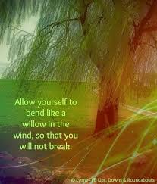  
**SONG: RESILIENCE**  
by Jenn Grinels- Single

Took a shot, all for not now you feel so low don't know which way to go  
  
Say you just can't do this anymore, Well, I know you can, cuz I've seen you here before  
  
sometimes you get so dark  
  
You don't recall the light  
but i've seen you come back from worse, dust off and win the fight  
  
  
I know you're tired and confused, we've all been there, calloused and bruised  
  
  
You will find the sun again  
and until then, my darling  
keep remembering  
resilience is a beautiful thing  
  
  
I know these times go slow  
I know the healing hurts  
  
But we were made to mend and break and mend again  
  
and when you're in the midst it's hard to see  
  
but someday I'll be where you are and you will say   
to me you will find the sun again  
and until then, my darling  
keep remembering  
  
Resilience is a beautiful thing.

**I AM STRONG** by Liz Clarke  
**CD:** the Dream

I am strong in the Lord

and in the power of His might

I am strong in the Lord

and in the power of His might.

He is my refuge , my strong tower

In him, I place my trust.

he is my refuge, my strong tower

And in him i place my trust.

The Lord is my salvation, whom shall I fear?

The Lord is my salvation whom

shall I fear?

The Lord is my salvation whom

shall I fear?

The Lord is my shepherd, I’ll not want. He makes me down to life.

In pastures green, he leadeth me

The quiet waters that

My soul he does restore again

And doth to walk again.

Within the paths of righteousness he will pour his own namesake

He is my refuge, my strong tower

In him, I place my trust.

He is my refuge my strong tower

In him, I place my trust.

For I am strong in the lord

and the power of his mind.

I am strong, in the Lord

and in the power of his mind.

**SONG**: “Serenity Prayer” Laverne Craig, CD: Serenity

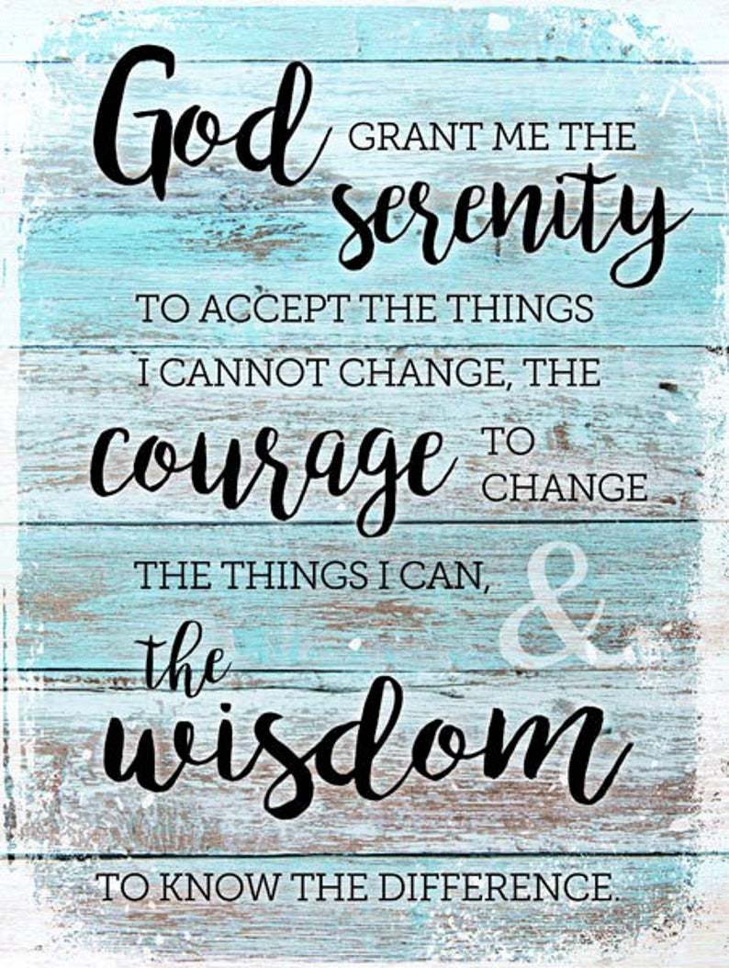

**TWCD Virtual Women’s Choir**

<https://youtu.be/ULngW8fd8iI>

**SONG:RESILIENCE** -By Abby Betinis   
  
Resilience we are strong; shoulder to shoulder keep moving on, resilience, make a new plan

Stand up again and say   
Yes we can.   
Resilience.

Resilience, we are strong; shoulder to shoulder keep moving on, resilience, make a new plan

Stand up again and say   
yes we can.   
Resilience.

Oh oh! We are strong; hold on! I wanna make it and  
I know we will, yes it’s

Hard to keep going but   
it’s worse to stand still. Resilience.

Additional options:

100, 000 people <https://youtu.be/_ZEhTYcJlmM>

**REMIX:** <https://youtu.be/mimM4uxjE-Y>