**Nautilus Symbolism** for creative response....  
  
 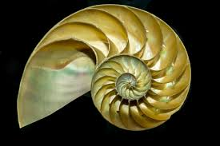

* Spirals are one of the oldest symbols. They symbolize the slow reveal of things that are hidden. It can mean growth and evolution.
* The ancient spiral would represent the way the universe would evolve. It would symbolize female energy, fertility, and womb.
* Nautiluses are known to outgrow and build up to 30 chambers in the course of their adult lives. Nautilus keeps these inner chambers filled with gas to help control its buoyancy. When it wants to dive, it adds water to the chambers
* Symbol for inner beauty of nature and of life and internal harmony.
* The chambers of the nautilus shell are symbolic of the stages one passes through in life.
* Spiral is a symbol of creation, movement,   
  fluidity, evolution
* Chambered nautilus is a cephalopod (a type of mollusk) The shell itself has many closed interior chambers or “compartments.”
* The spiral of the nautilus is not just any spiral. Measuring it reveals that it conforms to the shape of the Golden Ratio spiral, what is known as a "sacred geometry".

Nautilus is a symbol of strength because it can also withstand very high pressures in the ocean.   
***\*Reflection questions are on the  
 Nautilus Line image handout***© Stella DeVenuta, OSF (2020) stellaosf@lakeosfs.org

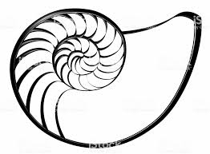***The antechamber  
of the nautilus chambered is the sea.  
The antechamber of the mystic is Divinity.****By Saiom Shriver*

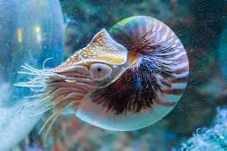 **Nautilus Vanquished**

“*The periscopic vision   
Of your surreptitious Nautilus  
Intruded upon my Atlantis  
To explore my exploding passions   
And conquer it.  
  
Through kaleidoscopic lenses,   
I let the curious you   
Behold my unravished civilization   
My femininity as untrampled snow,   
A hidden Proserpine,   
Breathing dormant   
Amidst the coral reef   
Of my veiled sensuousness.  
  
Do you know why?  Only to show you, Captain Nemo  
That the ocean bed isn’t necessarily sterile  
Just because it’s not flaunted before public eye,   
Nor meant to be enmeshed craftily,   
But conserved with caution you be cherished only   
by the navigator prudent enough to treasure it. “  
-Hazel Nut*

*“If we can be courageous, one more time than we are fearful; if we can be trusting, one more time than we are anxious; if we can be cooperative, one more time than we are competitive; if we can be forgiving, one more time than we are vindictive; if we can be loving, one more time than we are hateful . . .   
we will have moved closer to the next breakthrough in our evolution.” — Jonas Salk*