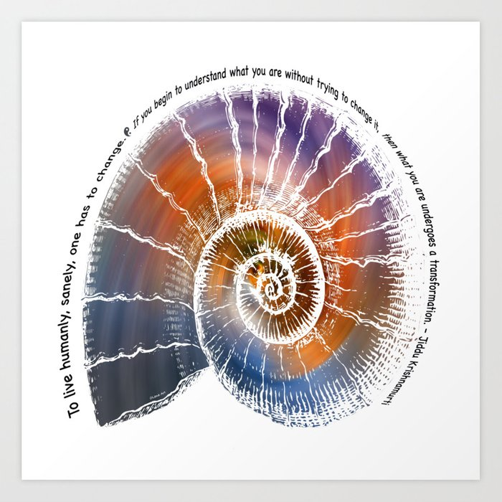  
  
*“To Live humanly, Sanely,   
one has to change.   
To begin to understand what   
you are without trying   
to change it, then what you are   
undergoes a transformation.”*

*To have compassion means to Have passion for*[*all*](https://en.wikiquote.org/wiki/All)*things,   
not just between two people,   
but for all human beings,   
for all things of the earth,   
the animals, the trees,   
everything the earth contains.   
  
When we have such compassion,   
we will not despoil the earth   
as we are doing now,   
and we will have no wars.*

**Jiddu Krishnamurti** (May 11 1895- Feb. 17 1986)   
Jiddu was a spiritual teacher, speaker and writer on Psychological, spiritual and sociological subjects.

© Stella DeVenuta, OSF (2020)   
 stellaosf@lakeosfs.org

  
  
*“To Live humanly, Sanely,   
one has to change.   
To begin to understand what   
you are without trying   
to change it, then what you are   
undergoes a transformation.”*

*To have compassion means to Have passion for*[*all*](https://en.wikiquote.org/wiki/All)*things,   
not just between two people,   
but for all human beings,   
for all things of the earth,   
the animals, the trees,   
everything the earth contains.   
  
When we have such compassion,   
we will not despoil the earth   
as we are doing now,   
and we will have no wars.*

**Jiddu Krishnamurti** (May 11 1895- Feb. 17 1986)   
Jiddu was a spiritual teacher, speaker and writer on Psychological, spiritual and sociological subjects.

© Stella DeVenuta, OSF (2020)   
 stellaosf@lakeosfs.org

  
  
*“To Live humanly, Sanely,   
one has to change.   
To begin to understand what   
you are without trying   
to change it, then what you are   
undergoes a transformation.”*

*To have compassion means to Have passion for*[*all*](https://en.wikiquote.org/wiki/All)*things,   
not just between two people,   
but for all human beings,   
for all things of the earth,   
the animals, the trees,   
everything the earth contains.   
  
When we have such compassion,   
we will not despoil the earth   
as we are doing now,   
and we will have no wars.*

**Jiddu Krishnamurti** (May 11 1895- Feb. 17 1986)   
Jiddu was a spiritual teacher, speaker and writer on Psychological, spiritual and sociological subjects.

© Stella DeVenuta, OSF (2020)   
 stellaosf@lakeosfs.org