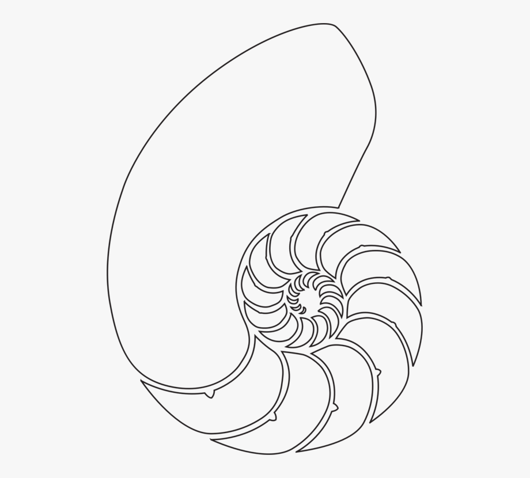

**SUGGESTED REFLECTION QUESTIONS TO PONDER ...** (choose ONLY 1 or 2 to respond to...you have many   
days ahead to continue to utilize the remaining questions...)

* Where does your inner strength live?
* Name some significant “chambers” you have “grown” throughout your life span
* Did either poem or a quote touch an inner space of inner truth?
* What influences the “sacred geometry” of your being?
* Do you recognize your hidden strengths?
* How do you find balance to maintain your inner harmony during these challenging days?

© Stella DeVenuta, OSF (2020) stellaosf@lakeosfs.org